

**Central banks and digital currencies**

Speech given by

Ben Broadbent, Deputy Governor for Monetary Policy, Bank of England

London School of Economics Wednesday 2 March 2016

I would like to thank Robleh Ali, Victoria Cleland, Grellan McGrath and other colleagues at the Bank for helpful comments and suggestions. The views expressed are my own and do not necessarily reflect those of the Bank of England or other members of the Monetary Policy Committee.

# Introduction

Hello!

This morning I’m going to talk about money.

This should be a routine topic for a central banker, particularly one whose job title includes the word “monetary”. It’s nonetheless ground on which one treads with a bit of trepidation. That’s partly because some of the big questions involved – what money is, why it exists, how and by whom its supply should be governed – seem to evoke very strong opinions. Even the great economist John Hicks, formerly of the LSE, confessed in the 1930s to some nervousness about expressing his views about the matter: “It is with peculiar diffidence and even apprehension that one ventures to open one’s mouth on the subject of money”.

It’s also because my particular focus – so-called “digital” currencies, including the possibility of a central bank variety – is an area of active interest and research, including at the Bank of England. So rather than try and give a lecture on monetary theory, or pre-empt the results of ongoing thinking on this issue, I’ll seek to make only a few very broad, conceptual points, touching on the following questions: what is the key innovation in private-sector digital currencies such as bitcoin? what is a “central bank digital currency”? and what might be the economic implications of introducing one?

I’ll be brief about the first, not least because there are good, more detailed descriptions elsewhere – including in two excellent articles by Bank economists, published some time ago in the Quarterly Bulletin. The main point here is that the important innovation in bitcoin isn’t the alternative unit of account – it seems very unlikely that, to any significant extent, we’ll ever be paying for things in bitcoins, rather than pounds, dollars or euros – but its settlement technology, the so-called “distributed ledger”. This allows transfers to be verifiably recorded without the need for a trusted third party. It is potentially valuable when there is no such institution and when verifying such information on a multilateral basis is costly.

Acting as a trusted third party is precisely what a central bank does. It performs that role only for one particular asset, central bank money (i.e. reserve deposits held largely by commercial banks at the central bank). But the function goes right to the heart of what central banks do and how they came about. And if a private-sector digital currency uses the technology to substitute for a third-party clearer, the central bank counterpart would do the opposite. The aim would be to widen access to the central bank’s balance sheet, beyond commercial banks. There’s no rigid correspondence here: in principle, one could introduce the technology and preserve the current arrangements, under which it is commercial banks that hold central bank deposits; it’s also possible to increase the number of counterparties without it. But the distributed ledger would probably make it easier to do so. That might mean adding only a narrow set of counterparties – perhaps a wide range of non-bank financial companies, say. It might mean something more dramatic: in the limiting case, everyone – including individuals – would be able to hold such balances. So although they

might share the same technology, and the same name, the private and central-bank versions of a digital currency are actually rather different. The one would expand what the other seeks to replace.

As far as its economic effects are concerned, my guess is that much would depend on how exactly a central bank digital currency (CBDC) is designed – and in particular the extent to which it competes with the main form of money in the economy, commercial bank deposits. As individuals, we already have the ability to hold claims on the central bank, in the form of physical cash. If all a CBDC did was to substitute for cash – if it bore no interest and came without any of the extra services we get with bank accounts1 – people would probably still want to keep most of their money in commercial banks.

But even then it’s likely you’d see some money moving out of existing deposits. That drain would be greater the more closely a CBDC resembles a genuine bank account. One imagines it would also be

counter-cyclical – resources would flow out of commercial banks during times of financial stress, back towards them when risk aversion is low.

Shifting deposits to the central bank, and away from the leveraged commercial banking sector, has two important implications. On the one hand, it would probably make them safer. Currently, retail deposits are backed mainly by illiquid loans, assets that can’t be sold on open markets; if we all tried simultaneously to close our accounts, banks wouldn’t have the liquid resources to meet the demand. The central bank, by contrast, holds only liquid assets on its balance sheet. The central bank can’t run out of cash and therefore can’t suffer a “run”.

On the other hand, taking deposits away from banks could impair their ability to make the loans in the first place. Banks would be more reliant on wholesale markets, a source of funding that didn’t prove particularly stable during the crisis, and could reduce their lending to the real economy as a result.

This is the really main point I want to get across. Some suggest that central banks will have to issue their own digital currency – i.e. to supply central bank money more widely, via some generalised distributed ledger

– to meet a “competitive threat” from private-sector rivals. I suspect a more important issue for central banks considering such a move will be what it might mean for the funding of banks and the supply of credit.

# Private-sector digital currencies: The distributed ledger

After that rather lengthy introduction, let’s begin with a brief over-view of what a “digital currency” is. As I say, I won’t take long over this. It’s a rich topic, goodness knows there are people who know more about computers than I do, and you can find a very good and more detailed description in the autumn 2014 edition of the Bank’s Quarterly Bulletin.

1 I’m thinking here of things like direct debits, or the capacity to receive our monthly pay.

One thing those articles make clear is that the key innovation introduced by something like “bitcoin” is not so much that it’s “digital”, if by that we mean that balances are stored electronically. At least in developed economies the overwhelming majority of money has long been held in bank accounts, rather than as physical cash (Chart 1 plots the history of both in the UK); almost since their invention, computers have been used by banks to record transactions between, and balances on, such accounts. If a “digital” currency is one whose accounts are little more than a series of zeros and ones on some distant electronic machine, well

that’s long been the case.

And if the word “currency” indicates an alternative unit of account – the “bitcoin”, for example – nor is this likely to be of enduring significance. You can find goods and services quoted in bitcoin. In the

United States, at a rough guess, there may have been as much as $5bn worth of such transactions last year2. But in a country where annual consumer spending is twelve and a half trillion dollars, that’s a negligible proportion of the total. In the opinion of most economists, it’s pretty unlikely that its use as a means of exchange will become very widespread.

|  |  |
| --- | --- |
| **Chart 1 Most money held in bank accounts, not as physical cash** | **Chart 2 Value of bitcoin is very volatile** |
| Sources: Hills, Thomas and Dimsdale (2015)3 and Bank of England | Source: [http://blockchain.info.](http://blockchain.info/) |

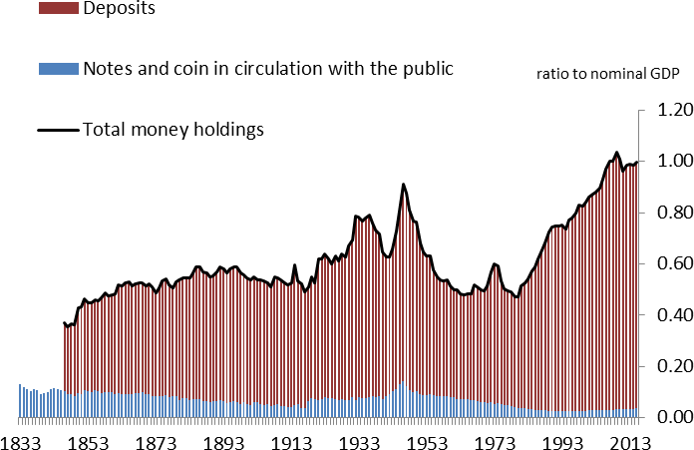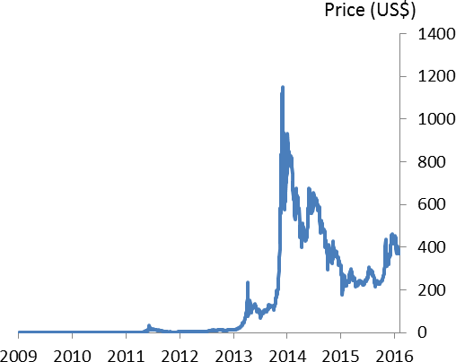It’s not just that the value of bitcoin is extremely volatile, though that’s certainly been the case (Chart 2; see also Ali et al (2014a and 2014b) and Yermack (2013) for the shortcomings of Bitcoin as a useable money). One should also recognise that established currencies have a significant built-in advantage. Rather like a common language, the benefit to any individual of using a particular unit of account is greater if others use it too. That gives a big head-start to the incumbent. Switches do very occasionally happen: degrade a currency sufficiently, via hyperinflation and collapse of the banking system, and people will eventually look

2 According to Coinbase, around 20% of bitcoin transactions – worth $25bn in total – were for retail purposes.

3 From 1997 total money holdings in the UK are given by notes and coin in circulation with the non-bank public plus the sum of households', PNFCs ' and non-intermediate OFCs' deposits (M4x). Prior to 1997 total money holdings are given by total M4 excluding repos and other short-term paper.

for alternatives. But that’s generally the sort of thing that has to happen: almost always, these currency substitutions occur only once the existing currency has become deeply compromised4. Even then, the thing people naturally reach for is an existing, trusted currency – often the US dollar – rather than some entirely new unit of account.

So if it’s neither the “digital” nor the “currency” aspect of bitcoin that matters, what is it that has sparked so much interest? Well perhaps a better name for what we’re talking about, albeit more of a mouthful, is a “decentralised virtual clearinghouse and asset register”. As the Quarterly Bulletin articles explain, the key innovation in bitcoin is its settlement mechanism. Instead of relying on an independent third party to process and record transactions, holders of bitcoin use a decentralised computer system called the “distributed ledger”. The distributed ledger works by encouraging users to verify for themselves, and others, blocks of transactions made over time. As everyone in the system has the right to do this, and everyone can see the results, there is no need for a trusted, centralised clearer.

In principle, this technology could be applied to many things, not just the exchange and registering of financial assets. A recent official report in the UK suggested that distributed ledgers might eventually be used for a wide variety of government services, including the collection of taxes, the delivery of benefits – potentially including new “smart” transfers that could target particular groups – the keeping of business registers and other things besides5. If so, then there may be similar potential uses in the non-financial private sector.

However, it’s the application to the settlement of financial assets – above all financial securities like equities and bonds – in which the private sector has become most interested. There are several new firms seeking to exploit the opportunity.

It remains to be seen whether these ventures prove successful. But one can understand why they’ve come about. What a distributed ledger would seek to replace, in the case of securities exchange, isn’t just a single “third-party centralised clearer”, but a complicated system with lots of institutional layers: custodians who look after the securities and perform basic services such as collecting dividends; brokers, through whom trade orders are placed; exchanges and clearing houses where exchange and settlement occur. Each has its own particular function in the process; at each stage, there may be a degree of settlement risk; each is obliged to keep its own record of the same balances and transactions.

It’s hard to know the combined cost of these services, but a recent study estimated that, in the G7 countries, the cost of clearing and settling securities was $54bn a year6. These are the economic resources it requires

4 New currencies have sometimes been introduced by executive decision and in an orderly way. The most obvious example is the euro. But when currency substitution has occurred naturally it’s almost always done so only after the incumbent currency has been debauched by hyperinflation.

5 Walport (2016).

6 Autonomous Research (2016).

to transfer the assets, verify who owns what, and reconcile the various records. The hope is that, by displacing these various middlemen, a distributed ledger would result in a cheaper and more secure system for providing these services.

# Central bank digital currency: who can bank at the central bank?

What, then, of the exchange of money, the particular asset for which the distributed ledger technology was originally conceived? Well that too has its own layers. Broadly speaking, at least for a given currency, there are two: commercial banks and the central bank.

As we saw in Chart 1, most of what you and I consider money is held as liquid claims on commercial banks,

i.e. deposits. Most transactions in the economy involve transfers of these claims. That’s obviously a straightforward matter if the two parties to the transaction use the same bank. When there are different banks involved – and that’s going to be true most of the time – there needs to be a means by which one can transfer money to the other.

This is done using their deposits at the central bank – so-called “reserves”7. That’s why the central bank is sometimes called “the banker’s bank”, and why reserves are often described as “the ultimate settlement asset”. The function of settling inter-bank transfers lies at the heart of what central banks do and, arguably, explains how they came about (Shafik (2016); see also Goodhart (1988)).

A “central bank digital currency” (CBDC) would involve putting these reserve deposits on a distributed ledger. And if it allows for securities to be exchanged more cheaply and securely, might the same not be true for these money balances?

Yes, presumably. It’s not clear the savings would be as large as those for exchanging securities. The current set-up, which has the central bank as a single hub through which all inter-bank transfers take place, already involves significant economies of scale. That’s precisely the advantage of having a single, trusted third party at the centre: you don’t need so many layers to begin with. There are certainly new technologies that can reduce, and indeed already are reducing, the costs of the front end of the existing payments system (i.e. the flow of commercial bank deposits round the economy). The ability to pay one’s bills over the internet is a case in point: the more that happens, the less the need for expensive bank branches. But that is happening independently of any changes at the back end of the system, by which I mean the infrastructure for exchanging central bank money. Compared with securities settlement, that process simply has fewer middlemen for a distributed ledger to replace.

7 Banks can also transfer resources by buying and selling their own short-term debt in the “money market”, but ultimate settlement is made by exchanging central bank reserves.

However, things do not end there. The point about the new technology is not just that it might make exchanging assets more efficient, to a greater or lesser extent. In principle, it also makes it easier to widen the access to those assets, perhaps dramatically so. If you create a platform on which the existing participants can more easily exchange central bank money, why not extend the right to others?

As I said in the introduction, this certainly isn’t impossible under the current settlement system, known as RTGS (for Real Time Gross Settlement). There are already some non-bank institutions that have access to the Bank of England’s regular facilities8. As my fellow Deputy Governor Minouche Shafik recently explained, the Bank is currently undertaking a review of RTGS and the question of access will be one of the issues involved (Shafik (2016)).

But it seems likely that a distributed ledger would make that process easier, opening up the balance sheet to a wider variety of financial firms. One might go further, giving access to non-financial firms, or perhaps even individual households. In the limit, a distributed ledger might mean that we could all of us hold such balances.

If so, our accounts would no longer be a claim on commercial banks but, like banknotes, the liability of the central bank.

# Would it compete with cash or with bank deposits? The CBDC and “narrow banking”

But which would it be – an actual bank account, with all the extra services such things entail, perhaps including the payment of interest; or simply “e-cash” – something that can only be used for retail transfers and doesn’t receive any interest?

This is an important question. If all it did was to reduce the demand for physical cash, it’s not clear the macroeconomic effects of a CBDC would be that significant. It’s possible the retail payments system might become more efficient. It’s also true that, were a CBDC fully to displace paper currency, that would open the door to the possibility of materially negative interest rates (Buiter (2009), Rogoff (2014), Haldane (2015)).

But that would require explicitly abolishing cash, not just introducing an electronic alternative. As long as it’s possible to hold something with a guaranteed nominal return of zero there’s a similar lower bound on all other forms of money, whether reserves at the central bank or a more widely available CBDC. Leaving aside the question of whether or not you should actively get rid of banknotes9, a purely cash-like version of a CBDC would mainly involve substituting one zero-yielding liability of the central bank for another.

8 Carney (2013).

9 Nor is it a live issue for the Bank. As the Governor recently said to the House of Commons’ Treasury Committee, “May I…be absolutely clear: there are no plans to abolish cash at the Bank of England”.

It seems to me that the more material effects of a CBDC would arise if it provided competition not just for banknotes but for commercial bank deposits as well. It’s not simply that there’s more money to play for (remember how much more is held in bank accounts). It’s that the assets backing the two are qualitatively quite distinct. Shifting resources from one to the other might therefore have an important effect on the relative supplies and prices of those assets.

Charts 3 and 4 make the point. Modern commercial banks, whose sterling balance sheets are aggregated in Chart 3, have what is called a “fractional reserve” structure. Their holdings of liquid assets, including reserves at the central bank, are much smaller than their deposit liabilities (the purple bar). Most of their assets are loans.

But loans are “illiquid”: there’s no secondary market in which to sell them and, at least in the short run, their value to the creditor cannot be easily realised. Indeed, when banks attempt to do so – by demanding early repayment or abruptly curtailing lines of credit – they can cause great economic damage, as we

(re-)discovered after the 2008-09 crisis.

This “maturity transformation” – the combination of on-demand liabilities and illiquid assets – imparts an inherent fragility to commercial banks’ balance sheets. If everyone tried simultaneously to withdraw a bank’s deposits, it wouldn’t have enough liquid resources with which to meet the demand. That’s why banks are vulnerable to “runs”. Taken with the economic costs of deleveraging, it’s also why society regulates and under-writes the banking system, via deposit insurance and central banks’ lender-of-last resort facilities.

|  |  |
| --- | --- |
| **Chart 3 Fractional reserves: Commercial banks’ liquid assets smaller than deposit liabilities** | **Chart 4 Central bank holds only liquid assets** |
| Source: Bank of England | Source: Bank of England Annual Report 2015 |

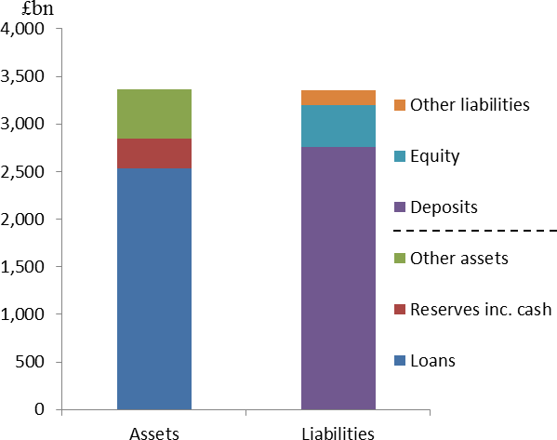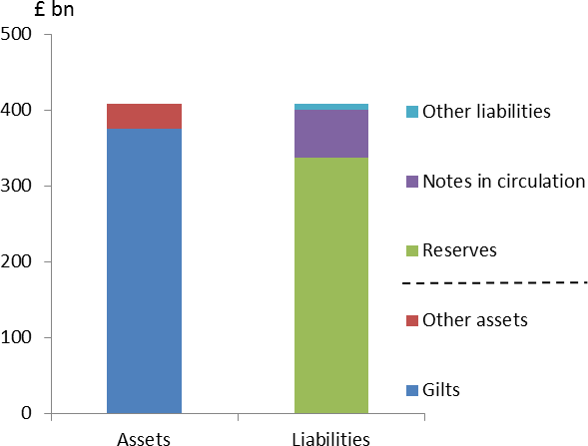By contrast, the central bank essentially holds nothing but liquid assets – largely government securities (Chart 410). Shifting deposits away from commercial banks, and towards the central bank, would therefore make for a “narrower” banking system – a “narrow” bank being one whose assets are as liquid as its liabilities. In principle, it would also make for a safer one. Backed by liquid assets, rather than risky lending, deposits would become inherently more secure. They wouldn’t be vulnerable to “runs” and we would no longer need to insure them.

The case for narrow banks has a long and distinguished pedigree. The classical economists Adam Smith and David Ricardo favoured such a system. Famously, during the Great Depression, a group of economists at the University of Chicago recommended the end of fractional reserve banking (the so-called “Chicago Plan”). There have been similar calls since the 2008-09 financial crisis11.

Proponents of narrow banking have generally argued it should be imposed by regulatory fiat, rather than via some sort of nationalisation of deposit-taking by the central bank. An exception is a 1987 essay by the economist James Tobin12. To avoid relying too heavily on deposit insurance to protect the payments system, Tobin argued, the government should create what he called “deposited currency accounts” (DCAs) at the central bank. “I think the government should make available to the public a medium with the convenience of

10 The Bank of England’s balance sheet has obviously grown following QE. Those operations have been conducted via the

Asset Purchase Facility (APF), which is not directly on the Bank’s balance sheet – strictly speaking, the blue bar in Chart 4 is not direct holdings of gilts but a loan from the Bank to the APF. But the APF itself holds only gilts and, even before QE, the vast majority of assets on the Bank’s balance sheet were government securities.

11 Ricardo, writing at a time when money was held largely as physical cash, argued the note issue should be separated and protected from commercial lending (Ricardo (1823)). The specific proposal in the Chicago Plan was 100% reserve requirements on demand

deposits of commercial banks (Simons et al., (1933)). The post-crisis case has been put by Pennachi (2012) and, amongst others, by Martin Wolf of the FT (Wolf (2014)). Lainà (2015) describes how calls for full-reserve banking tend to intensify after financial crises. Bossoni (2001) provides a useful overview of the literature on narrow banking and comes to a more sceptical conclusion. A longer-term perspective on the debate is provided by Goodhart and Jensen (2015).

12 Tobin (1987); there are echoes of this proposal in the more recent work of Barrdear and Kulmhof (2016).

deposits and the safety of currency, essentially currency on deposit, transferable in any amount by check or other order.”

There are two interesting points about Tobin’s proposal. One is that he made it long before anything like the “distributed ledger” was conceived (he suggested that DCA branches could be housed in post offices).

Another is that he fell short of suggesting the wholesale nationalisation of deposit-taking: he thought there should still be room for commercial banks to raise deposits of their own and that they should continue to be insured13.

One reason is that draining deposits from commercial banks is unlikely to be costless. In particular – and this is the potential catch with too widespread a CBDC – it might threaten their lending activity. If banks cannot use deposits for that purpose, how would their lending then be financed? And without a supply of bank credit, how would the real economy, in particular the part of it that cannot easily access securities markets, itself be funded?

There is no easy answer to these questions. As far as the non-financial economy is concerned, it’s clear it would be hard seamlessly to replace bank loans with securities issuance. There are good reasons why it’s difficult for young firms, in particular, with little invested capital, to sell shares or bonds14. The same goes for households. If bank lending became scarcer, or more expensive, it’s likely that investment and economic activity would suffer.

Furthermore, several economists argue that there’s a degree of complementarity between making loans, on the one hand, and issuing liquid liabilities on the other15. If so, you’d naturally expect to find the same institutions doing both – banks don’t exist in the form they do simply because we’ve partially insured their liabilities. And, at least to a degree, competing away their deposits would compromise banks’ ability to supply credit, or at least make it more expensive.16

It might also make that supply more variable. With an easily available alternative, banks’ remaining deposits would more readily migrate to the CBDC during times of stress. (It would certainly be more straightforward than stuffing cash under the proverbial mattress17.) Nor has the alternative source of funding the banks –

13 Under his proposal, however, deposit-taking banks would be “ring-fenced” from providing investment-banking services. Even so, commercial bank deposits would have to offer more attractive terms – in particular a higher rate of interest – than the DCAs. One implication is that, if the appropriate spread between the interest rate paid on commercial and central bank deposits were to widen during times of banking stress – and one imagines it would – the central bank would more often run up against the zero lower bound. 14 See, for example, Diamond (1984); a useful summary can also be found in Freixas (2008).

15 Kashyap et al. (2002) point out that there are technological similarities between holding deposits and making advances: both involve expertise in liquidity management. Diamond and Rajan (2001) go further, arguing that, given imperfect information on the part of

depositors about the riskiness of individual loans on a bank’s balance sheet, the risk of a run is a necessary discipline on the bank.

16 If maturity transformation is a necessary feature of a market economy, you’d probably expect to find the private sector creating an alternative supply of liquid assets of its own, to help replace lost deposits. This would mitigate the impact on lending but it would also undermine any prudential benefits of a part-nationalised deposit-taking system (e.g. Goodhart and Jensen (2015)).

17 Other than cash, the easiest way for individuals to shift exposure away from commercial banks and towards the safer public-sector

balance sheet is to put money into National Savings and Investment certificates (NS&I). Flows into NS&I picked up markedly during the crisis (NS&I (2009)).

raising debt in wholesale markets – proved that stable in the past. In fact, one striking feature of the financial crisis was that banks’ wholesale debt proved much less stable than deposits. That’s why regulators have since recommended that banks actually raise the share of (non-equity) funding that comes from deposits18.

It’s hard to know how significant these effects would be. And, as I tried to explain earlier, a CBDC that sought simply to replicate cash would probably have a greater impact on the demand for banknotes than on commercial bank deposits, with more limited macroeconomic effects. If the central bank’s balance sheet were opened up only to non-bank financial companies, and no wider, the issue probably wouldn’t arise to begin with.

But as you widen that access, and the more closely a CBDC substitutes for existing deposits – i.e. the further towards the south-east you move across (the extremely stylised) Chart 5 – the more prominent the issue becomes. No longer would a CBDC be a purely technical decision, about the costs and security of exchanging money. It would become more a matter of prudential policy, not to say the fundamental structure of the financial system.

# Chart 5: CBDC important when it competes with existing deposits Increased participation

NBFI All firms Whole economy



E-cash

Payment of interest, increasing provision of banking services

**Closer substitute for deposits**

Full-service accounts at CB

# Conclusion

The word “digital” has become so ubiquitous that its meaning isn’t always clear. The word seems to get tacked on to just about anything, no matter how tenuous its connection with computers, simply in order to convey an appealing sense of the modern. A brief search – on the internet, appropriately enough – reveals advertisements for a course in “digital humanities”, opportunities in “digital agriculture” and even something

18 The difference between loans and deposits – the so-called “funding gap” – has shrunk dramatically in recent years. Overall, the significant regulatory reforms since the crisis – in particular ring-fencing, the insistence on more equity and other loss-absorbing forms of funding and, on the assets side, higher holdings of liquid instruments – will have lowered materially the degree of maturity transformation within the banking system (see, for example, Lowe (2015)).

called “digital parenting”, whatever that is. (If it means having to ask your 11-year-old son what’s gone wrong with the computer then I would certainly qualify as a “digital parent”).

Whether or not “digital currency” is the right way to describe something like bitcoin, or its central bank counterpart, is also unclear. A better term for the underlying technology, the distributed ledger, might be “decentralised virtual clearinghouse and asset register”. But there’s no denying the technology is novel. Prospectively, it offers an entirely new way of exchanging and holding assets, including money.

It’s an irony, therefore, that some of the economic questions it raises have actually been around for a long time, for as long as economics itself. Some admirers of bitcoin see it as a means of bypassing central banks altogether. They are in some ways the descendants of the supporters of “free banking” in the 19th century. Conversely, others see the distributed ledger as an opportunity for the central bank to expand its role, via a “central bank digital currency” available to a much wider group of counterparties. If it were a close substitute for bank deposits, a CBDC would represent a shift towards a “narrower” banking system. This too is an old debate in economics: should banks be prevented from creating liquidity, or is maturity transformation an inevitable and necessary feature of market economies?

I’m certainly not attempting to enter that debate today. It’s in the nature of long-standing questions that the answers aren’t obvious. What I do want to do, however, is to point out that it is a relevant question – that the introduction of a CBDC probably involves more than a narrow, technical judgement about the efficiency of the payments system, very important though that is.

What’s also clear is that we have a lot more thinking to do. That’s why the issue of digital currencies forms an important part of our One Bank Research Agenda19. It’s also why, in publishing the Agenda a year ago, we asked for help, hoping to encourage “the wider academic community” to think about the big policy questions. So, in what is the heart of that community, and notwithstanding Mr Hicks’s caution, perhaps you’ll allow me to finish by re-iterating that request: all contributions welcome!

19 Bank of England (2015); see, in particular, section 5 “Response to fundamental change”.

# References

**Ali, R, Barrdear, J, Clews, R and Southgate, J (2014a)**, ‘Innovations in payment technologies and the emergence of digital currencies’, *Bank of England Quarterly Bulletin*, Vol. 54, No. 3 .

**Ali, R, Barrdear, J, Clews, R and Southgate, J (2014b)**, ‘The economics of digital currencies’, *Bank of England Quarterly Bulletin*, Vol. 54, No. 3, pages 276–86.

**Autonomous Research (2016)**, ‘Financials and technology, tales from de-crypt’.

**Bank of England (2015),** ‘One Bank Research Agenda’, Discussion paper available at [http://www.bankofengland.co.uk/research/documents/onebank/discussion.pdf.](http://www.bankofengland.co.uk/research/documents/onebank/discussion.pdf)

**Barrdear, J and Kumhof, M (2016)**, “The macroeconomics of central bank-issued digital currency”, *Bank of England Working Paper*, forthcoming.

**Bossone, B (2001),** ‘Should banks be narrowed?’, *IMF working paper* no. 159.

**Buiter, W (2009),** ‘Negative interest rates: when are they coming to a central bank near you?’, Financial Times article available at [http://blogs.ft.com/maverecon/2009/05/negative-interest-rates-when-are-they-](http://blogs.ft.com/maverecon/2009/05/negative-interest-rates-when-are-they-coming-to-a-central-bank-near-you/#_ftn1) [coming-to-a-central-bank-near-you/#_ftn1](http://blogs.ft.com/maverecon/2009/05/negative-interest-rates-when-are-they-coming-to-a-central-bank-near-you/#_ftn1)

**Carney, M (2013)**, ‘The UK at the heart of a renewed globalisation’, speech given at an event to celebrate the 125th anniversary of the Financial Times, London.

**Diamond, W (1984),** ‘Financial Intermediation and Delegated Monitoring’, *The Review of Economic Studies,*

Vol. 51, No. 3, pp. 393-414.

**Diamond, W and Rajan, R (2001)**, ‘Liquidity Risk, Liquidity Creation, and Financial fragility: A Theory of Banking’, Journal of Political Economy, Vol. 109, No. 2, pp. 287-327.

**Goodhart, C (1988),** ‘The evolution of central banks’, *MIT Press, Cambridge (Mass).*

**Goodhart, C and Jensen, M (2015)**, ‘A Commentary on Patrizio Lainà’s ‘Proposals for Full-Reserve Banking: A Historical Survey from David Ricardo to Martin Wolf’, *Economic Thought,* Vol. 4.2, pg 20-31.

**Haldane, A (2015)**, ‘How low can you go?’ speech given at the Portadown Chamber of Commerce, Northern Ireland.

**Hills, S, Thomas, R and Dimsdale, N (2015),** ‘Three Centuries of Data - Version 2.1", Bank of England.

**Harris, M and Raviv, A (1990),** ‘Capital Structure and the Informational Role of Debt’, *The Journal of Finance,* Vol. 45, No. 2 (Jun., 1990), pp. 321-349

**Kashyap, A, Rajan, R and Stein, J (2002),** ‘Banks as liquidity providers: An explanation for the coexistence of lending and deposit-taking’, The Journal of Finance 57, 33-73.

**Lainà, P (2015),** ‘Proposals for Full-Reserve Banking: History and Critique from David Ricardo to Martin Wolf’, Department of Political and Economic Studies, University of Helsinki, Finland.

**Lowe, P (2015),** ‘The transformation in maturity transformation’ speech given to Thomson Reuters’ 3rd Australian Regulatory Summit, Sydney, 27 May 2015.

**National Savings and Investments (2008-09),** Annual Report and Accounts available at <http://nsandi-corporate.com/wp-content/uploads/2014/02/13428-Annual-Report-Web.pdf>

**Pennacchi, G (2012),** ‘Narrow banking’, [*Annual Review of Financial Economics*, Vol. 4, pp. 141-159, 2012](http://papers.ssrn.com/sol3/papers.cfm?abstract_id=2170927) **Rogoff, K (2014),** ‘Costs and benefits to phasing out paper currency’, *NBER Working Paper* No. 20126 **Shafik, M (2016)**, A New Heart for a Changing Payments System, speech given at the Bank of England.

**Simons, H, Cox, G, Director, A, Douglas, P, Hart, A, Knight, F, Mints, L, Schultz, H (1933):** ‘Banking and currency reform’, Manuscript. [Reprinted in Samuels, Warren (ed.) (1990): *Research in the History of Economic Thought and Methodology*. Archival Supplement, Volume 4. Greenwich, CT: JAI Press.]

**Tobin, J (1987)**,’The Case for Preserving Regulatory Distinctions’, Federal Reserve Bank of Kansas City, 1987, pp. 167-183.

**Walport, M (2016)**, ‘Distributed ledger technology: beyond block chain’, Council for Science and Technology.

**Wolf, M (2014)**: ‘Strip private banks of their power to create money’, *Financial Times*, 24 April 2014.

**Yermack, D (2013)**, ‘Is Bitcoin a real currency? An economic appraisal’, *NBER Working Paper No. 19747*.